**Lab Workshop #12**

Purpose:

Exploring simulink

Simulink is an extension to Matlab that allows you to graphically represent and model a process. It is quite different from working directly with matlab. This lab works through creating a simple process and simulating it.

1. Launch the Matlab application from **NAL**. **Important:** *Change the working directory of matlab to your projects folder*, if you don’t simulink will fail to simulate and incorrectly save your models. Start the simulink by clicking on the  icon on the toolbar. You should see the Simulink library browser pop up.

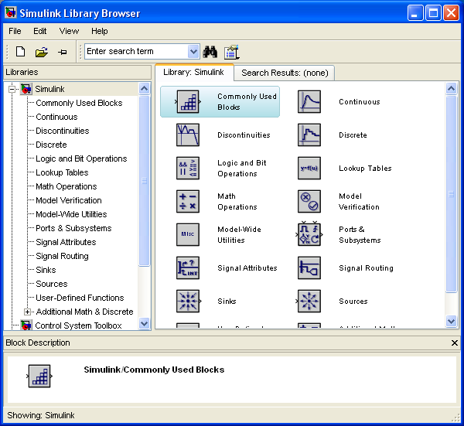

1. Click on the  icon to start a new project.
2. You can drag icons from the library browser to the new project. Double-clicking on an icon pops up a configuration panel. Using blocks from the “Commonly Used Blocks” pallete, create the following diagram:

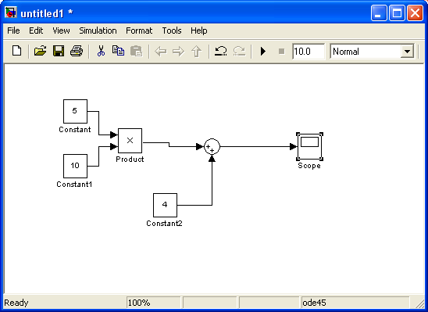

1. Note that (1) by double clicking on an icon, you can change it’s properties. And (2) you can connect the outputs of one block to the inputs of another by clicking on an output and dragging the arrow to an input .
2. Now run the simulation (Simulation->Start). To see the output in the “scope,” double-click on the scope icon and hit the auto-calibrate toolbar:

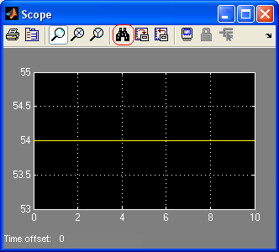

1. Save this as Lab12a.mdl (File->Save As in the Project panel).
2. Now create a new block digram for some simple math expression involving two or three math operations. Give the math expression here: __________________________, and save this as **Lab12b.mdl**.
3. Simulink is most valuable when working with signals that change in time. Using the sine wave generator in the Sources pallete, and the derivative block in the Continuous pallete, create the following process diagram for the derivative of 4*sin(x)+1

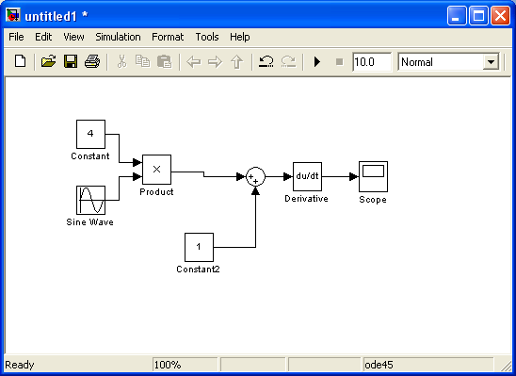

1. Save this model as Lab12c.mdl. Change the formula (write it here: _______________________________), and paste a screen shot of the scope output here:
2. This is the end of this lab and very short introduction to simulink.