# Lab Workshop #1

***Purposes:***

1. Familarization with windows XP
2. file management and use of shared drives
3. introduction to Microsoft Excel 2007

1. **Starting up**

Pressing a key on the keyboard usually brings the computer out of a sleep state. If the green power light on the CPU case is blinking, briefly pressing the power button will bring it out of hibernation. If there is no green light on the power button, pressing firmly will start the system. Note there is a separate power button on the monitor. It should be left on (they automatically go into a low-power mode when unused), but if they were turned off you will need to turn the monitor on as well.

You should see the novell login screen. Press CTRL-ALT-DELETE to bring up the task manager and log out if you need to.

NOTE: If you have one, you SHOULD NOT insert your portable drive/usb memory stick into the USB port before logging into your account. If you do, you may create a drive letter conflict that is tricky to fix and may prevent you from accessing your files on that computer.

You should LOG OUT after using a computer. This lets others users know that computer is available, and prevents others from accessing your files.

2. **Running Applications**

* You can find a file associated with that application (such as a spreadsheet you have been working on). Double-clicking on a file associated with an application will cause that application to start and open the file. You can find files using Windows Explorer, which is started by clicking on the  icon in the task bar.

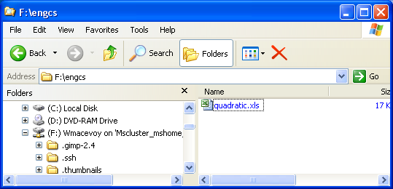

* You can start the application from the start menu . Recently used applications appear in this menu directly, and a more extensive list of applications is found by clicking on the All Programs arrow under the start menu.

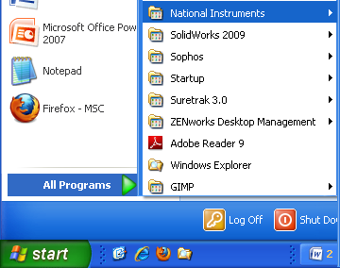

* Finally, the NAL launcher has a set of managed applications you can run. You can start Matlab, for example, by choosing the Matlab 2009a icon in the NAL launcher.

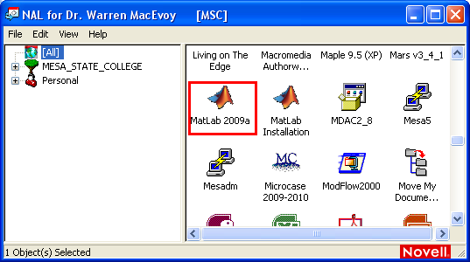

Depending on the situation, some of the elements shown above may be missing, and there may be additional elements.

Start word, create and save a simple document, then close word. Start it again by double-clicking on the document after finding it using windows explorer.

Do the same for excel.

1. **Where are your files?**

A home PC usually has a single storage device, called a hard drive, where you store permanent information. In windows, this is usually called the C: drive.

It is a bad habit on campus to think of files stored on the C: drive as permanent. The IT department regularly has to re-image computers with problems (which erases all the personal information on the drive), and as you move from one place to another, your data is stuck on the system where you created it.

A much better habit is to use the F: drive to save your work. This drive is a network drive, and you (and only you) have access to the data on that drive when you log into any of the computers on campus. If you need more space on the F: drive, you can ask the IT department for a larger allocation.

Additionally, we will be using the K: drive to share information.

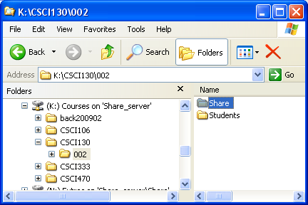

For each class with a K: drive mapping you are signed up for, you should find a similar layout of folders: the Share folder the instructor can write to and all the students can read from, while the Students folder has individual folders each student can write to and the faculty can read from.

These folders can be accessed from home using MavZone. Log into mavzone.mesastate.edu, and you will find the following widget on your front page:

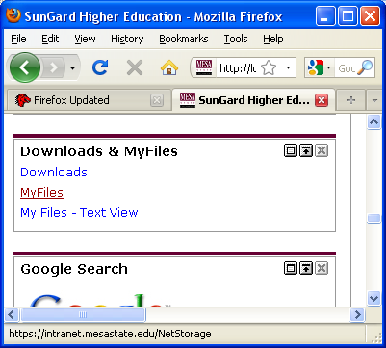

Choosing the “My Files” link and authenticating again will give you a web browser interface to access your files on the F: and K: drives.

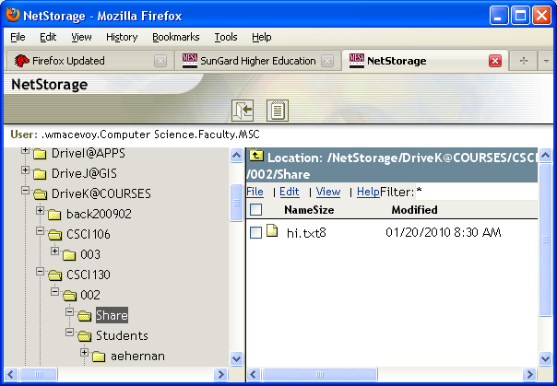

1. **A Brief Introduction to Excel 2007**

This short session is intended only to get your feet wet with Excel. Many, perhaps most of you have used Excel in the past. Pay attention to these exercises though because they will likely teach you how to do some things with Excel that you have not done before. Total immersion in Excel comes later on.

4.1 Start Excel from the Start menu

4.2 Layout of the Excel 2007 window

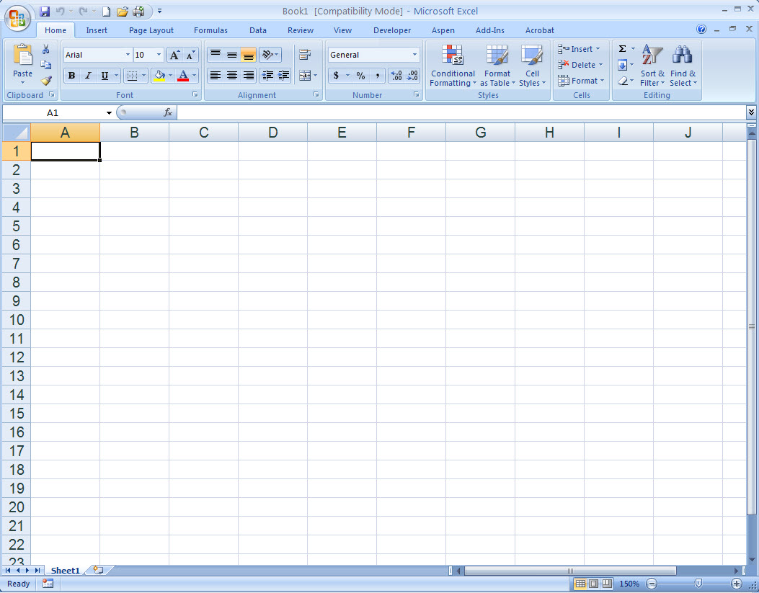

Apart from the spreadsheet area of the Excel window with its labeled columns and rows, there are other features you should take note of. Identify all these on your monitor display.



4.3 As you move your mouse pointer around the spreadsheet, you should notice that it takes on multiple personalities. Here are some examples:

Hollow plus (general cursor on the spreadsheet) Hollow arrow with small black pointer arrows

(shown at edges of the selection of cells)

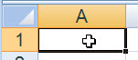 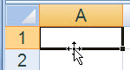

Fill handle (for “autofill” operations) Insertion point in the formula bar or name box

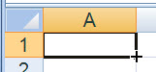 InsertionPoint

Column indicator Column separator (used for width adjustment)

ColumnIndicator ColumnSeparator

Row indicator Row separator (used for height adjustment)

RowIndicator 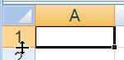

Hollow arrow (general operations outside the spreadsheet area)

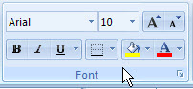

Move around the window and familiarize yourself with these different “looks” for the mouse cursor.

4.4 Making cell selections



When you start up Excel or open a new or existing spreadsheet, the A1 cell is selected. We denote a particular cell by its “address,” given by its column letter and row number coordinates.

In this case, the bold outline around the cell indicates that this single cell is the “selection.” Also, since there is only one cell selected, it is called the “active cell.”

There are two easy ways to move the selection/active cell. The first is a natural, just click on another cell that is within view.

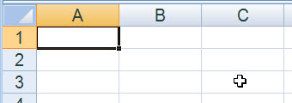 ⇨ 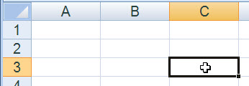

Next, use the arrow keys on the keyboard to move the selected cell up/down/right/left, one cell at a time. Try that out. It can be quicker to use the arrow keys if your hands are already on the keyboard.

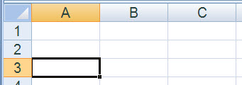

If you have selected cell C3, as shown above to the right, and press the Home key, you will see that the selected cell moves to column A in the same 3rd row.

If instead you hold down the Ctrl key and press the Home key, the selected cell will return to A1. Try that.

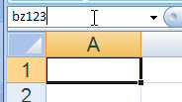

What if you want to select a cell that is “a long ways away” on the spreadsheet? An easy way is to type the cell address into the Name Box and press the Enter key. For example, try

and you will see that BZ123 appears selected in the lower right of your spreadsheet display. You can return to the “home cell” A1 by pressing Ctrl-Home again.

Now comes the matter of selecting multiple cells in a single selection. Perhaps the easiest way to do this is to “drag out” a rectangular selection with the mouse. Start by selecting the B2 cell by clicking on it. Then, with the hollow-plus mouse cursor in the middle of cell B2, hold down the left mouse button and drag the cursor to the middle of cell D4, then release the left mouse button.

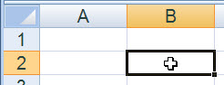 ⇨ 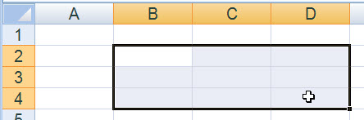

Notice that all the cells in the B2:D4 selection[[1]](#footnote-1) are shaded except B2. The B2 cell in this case is called the “active cell” within the “selection.” Press the Tab key and watch the active cell move within the selection. Press it several times. Try the BackTab (Shift-Tab) key combination too.

Select the home cell (Ctrl-Home) and try typing B2:D4 into the Name Box. The same selection should be made.

A second, useful way to make multi-cell selections is using the arrow keys with the Shift key. Select the B2 cell again. Hold down the Shift key. Press the down arrow key ( 🡫 ) twice and the right arrow key ( 🡪 ) twice. You should get the same B2:D4 selection.

You can then use the Shift-arrow key combinations to change the “shape” of the current selection, expanding it or contracting it. Try this. You can’t do this directly with the mouse, once the selection has been made, by either the mouse or the arrow keys; however, you can change the shape of the selection with the mouse if you hold down the Shift key. Practice this too.

There is much more to come regarding the basic skills of operating the Excel spreadsheet, and we will introduce that in future lab workshops. For now, you will set up a scientific calculation.

4.5 Example problem: gravitational attraction between the earth and the moon

Newton’s Law of Gravitational Attraction is given by 

where  force of attraction, N

 masses of the two bodies, kg

 distance between the two bodies, m

 universal gravitation constant, 

The masses of the earth and the moon are estimated to be

 

You will now set up a spreadsheet to implement the calculation of the force of attraction.

Select cell A1 and enter the title ***Gravitational Attraction Between the Earth and the Moon***. You will note that this title “overflows” cell A1 into cells to the right.

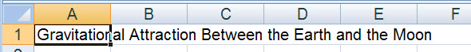

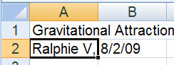

In cell A2, enter your name and the current date. It is always a good practice to put your name on a spreadsheet along with a “date stamp.”

In cell A4, enter the label, **Universal Gravitation Constant**, and, in cell A5, enter the label **G**. To the right, in cell B5, enter the value of G by typing

**6.673E-11** followed by the Enter key

This is the style for scientific notation in Excel (and in many other software programs including Matlab). In cell C5, enter a units label as follows

**N m2 / kg2** followed by the Enter key[[2]](#footnote-2)

GravitationalConstant

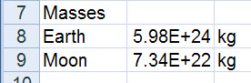 In cell A7, enter the label **Masses**, and in cells A8 and A9, enter the labels **Earth** and **Moon** respectively. To the right of the Earth and Moon labels, enter their respective masses in cells B8 and B9, and then enter labels **kg** in cells C8 and C9.

In cell A11, enter the label **Distance Between Mass Centers**. In cell A12, enter the label **d**, and to the right, in cell B12, enter the value

**3.84E8** and, in cell C12, enter the label **m**.

In cell A14, enter the label **Gravitational Attractive Force**, and, in the cell below it, A15, enter the label **F**.

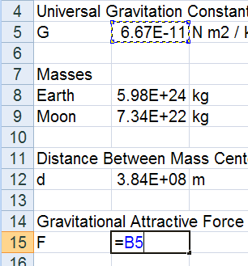 To the right of cell A15, in cell B15, you will enter the formula shown above to compute the gravitational attractive force. This is best done by using a spreadsheet technique called “pointing.”

start the formula in cell B15 by typing an equals sign, **=**

place your mouse cursor on the G value in cell B5 and click – you should see ⇨

then type an asterisk, \*, for multiply

and click on cell B8, earth’s mass

follow this with another asterisk, \*,

and click on cell B9, moon’s mass

type a forward slash, / , for divide, and

then click on cell B12, distance

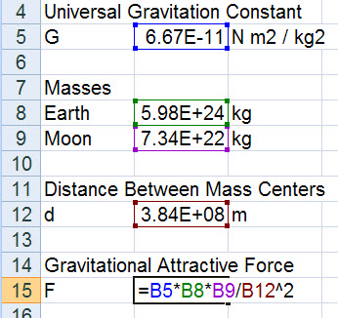

finish by typing ^2 for the squaring of the distance

you should see the color-coded formula as shown to the right ⇨

press the Enter key.

You should have the result below in cell B15, and the formula should be shown on the formula bar.

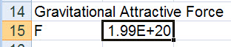

GravitationalFormulaBar

Enter a label **N** in cell C15 for the force units of newtons.

Select cell A5, the label G, and click the “right align” button, RightAlignButton, in the Alignment group of the Home tab on the ribbon. This should move the label to the right side of the cell.

G_right-aligned

In a similar fashion, right-align cells A8, A9, A12 and A15.

Your completed problem solution should now look like

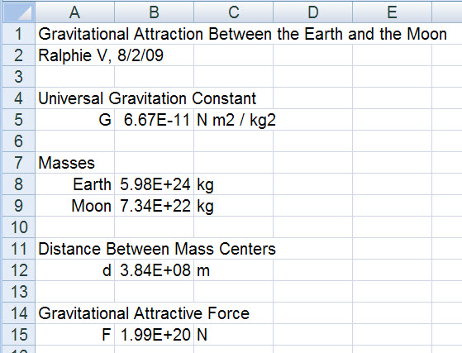

Save your Excel 2007 workbook to your K: drive. To do this, press the F12 key. This should give you the Save As dialog box.

Adjust the Save In: field at the top to the location on your flash drive, e.g., K:\CSCI130\001\Students\wmacevoy\Lab01\. Enter a file name

**EarthMoonGravitationAttraction**

and make certain the Save as type: field is

Excel Workbook (\*.xlsx)

then click OK.

4.6 Modify your example above to compute the gravitational attraction between the sun and the earth. Find any basic data you require via the internet.

Save your work on the K: drive.

5. **Log out on your computer**

***End of Lab Workshop #1***

1. Rectangular cell ranges in Excel are denoted like this, B2:D4, where the first cell address is the upper-left corner and the second cell address is the lower-right corner. [↑](#footnote-ref-1)
2. You will learn how to do a fancier job of formatting a label like this later on. [↑](#footnote-ref-2)