Test Plan 1 – Accuracy & Repeatability

*Objective:* This test determines whether the device can accurately identify a set location and repeat its actions 3 times within a tolerance of ±0.10 in​

*Factors Controlled*: Weight of frame, motor rotation speed, actuation process, drawing medium​

*Factor not controlled:* Friction​

*Independent Variables:* Stepper motor speed, drawing medium weight, delay times​

*Dependent Variable*: Set location​

*Pass/Fail Criteria:* System correctly marks set location within a tolerance of ±0.10in.​

*Setup Procedure*​

1. Back the motor up against the zeroed position​
2. Load g-code with 1'' square grid spacing ​
3. Measure square spacing deviations from 1'' spacings​
4. Repeat steps 2 and 3, three times​
5. Report the maximum deviation from each of the 1'' square spacing​

*Results*

After carefully following the set-up procedure for test plan 1, the graffiti bot’s 1” square spacing reported a maximum deviation of +/- 0.002 in. which is within the specified tolerance of +/- 0.10 in. after multiple tests. Therefore, this test plan has been PASSED and is capable of reporting accurate and repeatable markings which satisfies our engineering specification to demonstrate repeatability and accuracy on drawings.

Test Plan 2 – Marking Tip Durability

*Objective*: This test determines whether the drawing medium is durable enough to withstand the surface finishes including plywood, concrete, and canvas​

*Factors Controlled*: Drawing medium, surface (plywood /concrete)​

Factor not controlled: Friction​

*Independent Variables*: Durability of drawing medium​

*Dependent Variables*: Marking speed, direction of drawing lines, pressure applied​

*Pass/Fail Criteria*: Drawing medium plots consistent lines without severely damaging marking tip

*Setup Procedure*

1. Insert drawing medium in clamping device​
2. Back up motor into zeroed position to the bottom​
3. Input a g-code to plot a 12x12" square and inspect the line finish on the surface and marking tip finish​
4. Repeat step 2-3 three times on a plywood and concrete surface​
5. Report the visible contrast lines as durable​

*Results*

After carefully following the set-up procedure for test plan 2, the graffiti bot’s drawing medium (sharpie marker) was capable of drawing visible contrast lines and withstanding multiple surface finishes including plywood, concrete, and canvas. The concrete surface was the most rough while the sharpie image below depicts the tip after plotting 10ft. Therefore, this test plan has been PASSED and proves this is a durable marking tip while plotting which satisfies one of our engineering specifications.

Test Plan 3 – Linear shaft rods will not deflect while drawing on surface

*Objective:* This test determines whether the linear shaft rods of the graffiti bot will withstand the movement being performed while the drawing medium is drawing on the surface finish​

*Factors Controlled:* Weight of rods, surface supporting frame, motor rotation speed, actuation process​

*Factor not controlled*: Friction​

*Independent Variables:* Stepper motor speed, frame weight​

*Pass/Fail Criteria:* Frame placement is within ±0.05 in. from theoretical deflection calculation (-.0102 in.) ​

*Setup Procedure*

1. Place frame on flat ground while setting up markers taped to the outside of each corner on the ground​
2. Run g-code to run an image without the drawing medium inserted​
3. Measure any deflection from the original placement of the linear shaft rods
4. Repeat steps 2 and 3 three times, record both linear shaft rods deflections and report the maximum deviation both rods as the deflection.​

*Results*

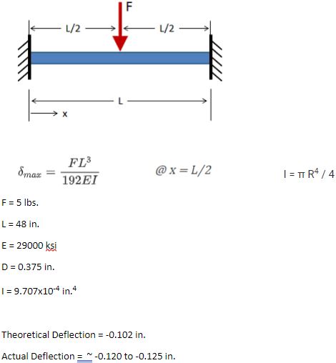After carefully following the set-up procedure for test plan 3, the graffiti bot did have some minor deflection. Although, our analyzed deflection came out to be about -0.0125 which is within the tolerance. Therefore, this test plan has been PASSED and proves the linear shaft rods will not deflect while the graffiti bot is plotting.

Test Plan 4 – Graffiti bot is capable of drawing complete image using 2.5' x 2.5' drawing area​

*Objective:* This test determines whether the graffiti bot will be able to draw images that take up the required drawing area of 2.5'x2.5' on each of the four sides​

*Factors Controlled*: Weight of frame, surface supporting frame, motor rotation speed, actuation process, drawing surface​

*Factor not controlled*: Friction​

*Independent Variables:* Stepper motor speed, frame weight, drawing medium​

*Dependent Variables*: G-code dot placement image​

*Pass/Fail Criteria*: Graffiti bot plots on desired g-code dot locations​

*Setup Procedure*

1. Back the motor up against the indicator fully depressing it​
2. Input the g-code image to plot dots along the perimeter of a 2.5'x2.5' drawing area​
3. Reset the drawing medium back to the zeroed position and measure the dots plotted along the perimeter​
4. Report the minimum perimeter area from the dots plotted as the drawing area​

*Results*

Following the procedure, running the biggest drawing area we could do came out to be 36”x32” which is well over the 30”x30” requirement. Therefore, this test plan has been PASSED which meets another engineering specification.

Test Plan 5 – Product weighs under 25 lbs. and is easily transportable​

*Objective:* This test determines whether the graffiti bot is easily transportable by two individuals​

*Factors Controlled*: Weight of system​

*Factor not controlled*: Distortion of assembly​

*Independent Variable*: Weight of system​

*Dependent Variable*: Transportation distance​

*Pass/Fail Criteria*: Graffiti bot weighs under 25 lbs. and Graffiti Bot doesn’t permanently distort during transport.​

*Setup Procedure*

1. Lie the graffiti bot onto the ground​
2. Have two people lift the graffiti bot by wood frame​
3. Relocate the graffiti bot 20 feet away from the original location​
4. Repeat steps 2 and 3, three times​
5. Report if there is any difficulty lifting or balancing the system from each person and report any distortion in the assembly ​

*Results*

Following the setup procedure, we weighed the product to be 17 lbs. and is easily capable of being transported by two people. While there wasn’t too much difficulty transporting the graffiti bot, the frame was at risk to distortion, so we just had to be extra careful with it and it was okay. Therefore, this test plan has PASSED and meets one of the engineering specifications.