Rover Test Plans
Test Plan 1 – Linear Distance
Objective: This test determines whether the rover can accurately identify a set distance and drive to it accurately in a timely manner.
Factors Controlled: Weight of chassis, motor rotation speed, floor terrain
Factor not controlled: Friction, drift
Independent Variables: Motor speed, chassis weight, delay times
Dependent Variable: Set location
Pass/Fail Criteria: Rover correctly drives to intended distance within ±10% of intended drive distance.
Setup Procedure:
- Place rover against specified zeroed position.
- Input code to drive forward for 10’.
- Measure drive distance traveled.
- Repeat steps 1-3, three times.
- Report the maximum deviation from the intended 10’ drive distance.
- Adjust Arduino code and repeat is necessary.
Results
Following the procedure setup for test plan 1, the rovers linear distance reported a maximum deviation of ±1 ft. during the successful test run settings. These values all stayed within the specified tolerance of +/-10% of the intended drive distance of 10’ after multiple tests. Therefore, the linear distance test plan has PASSED and shows the rover is capable of accurately identifying a set distance and driving to it linearly in a timely manner.
*Able to complete with Mission #1 capable rover
Table 1. Linear distance measurements with Arduino specifications
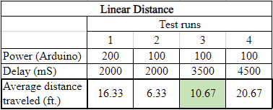
Test Plan 2 – Linear Drift
Objective: This test determines whether the rover is capable of driving straight to a specified distance without drifting to the left or right
Factors Controlled: Chassis wheels, flat surface
Factor not controlled: Friction
Independent Variables: Chassis wheels
Dependent Variables: Driving speed, direction of drawing lines, pressure applied
Pass/Fail Criteria: Rover drives to intended driving distance within 1.5’ of specified drive distance.
Setup Procedure:
- Place rover against specified zeroed position.
- Input code to drive forward for 30’.
- Measure linear deviation.
- Repeat steps 1-3 three times.
- Report the drift deviations.
- Adjust steering mechanisms and repeat if necessary.
Results
Following the setup procedure for test plan 2, the rovers linear drift reported a maximum drift deviation of 1.5’ with the drive servo setting at 100 and the physical alignment of the wheel drive at 45°. After multiple tests, all measured values of the final drive distance stayed within the 1.5’ radius while driving the intended drive distance of 30’. This shows that our linear drift test plan has PASSED and shows that our rover is capable of driving straight to a specified distance without drifting to the left or right dramatically.
*Able to complete with Mission #1 capable rover
Table 2. Linear drift measurements with drive servo specifications
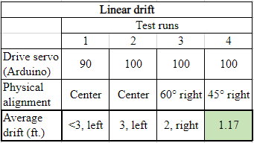
Test Plan 3 – Turn Accuracy
Objective: This test determines whether the rover will turn accurately while the rover is driving
Factors Controlled: Weight of chassis, motor rotation speed, servo motor
Factor not controlled: Friction
Independent Variables: Servo motor speed, chassis weight
Pass/Fail Criteria: Rover drives then turns within ±5° of specified turning radius
Setup Procedure:
- Place rover against specified zeroed position.
- Run code to drive straight for 10’ then turn left/right 90° then straight.
- Calculate actual turn angle.
- Repeat steps 1-3 three times, record the maximum deviation of turn angle.
- Adjust servo code and/or steering mechanism and repeat if necessary.
Results
After carefully following the setup procedure for test plan 3, the rovers turn accuracy reported a maximum deviation of ±5° when the drive servo was set at 1400 ad the delay was set at 1500 mS. After three test runs, all values stayed within the specified ±5° turning radius tolerance. Therefore, the turn accuracy test plan has PASSED and demonstrates the rover can turn 90° accurately while driving.
*Able to complete with Mission #1 capable rover
Table 3. Turn accuracy measurements with drive servo and Arduino specifications
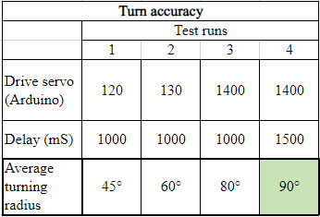
Test Plan 4 – Payload Drop
Objective: This test determines whether the rover will place the payload drop accurately within a specified location
Factors Controlled: Weight of chassis, payload drop mechanism, servo motor, placement surface
Factor not controlled: Friction
Independent Variables: Servo motor speed, chassis weight, payload drop mechanism
Dependent Variables: Driving route
Pass/Fail Criteria: Rover places payload drop within 1’ radius of specified drop zone
Setup Procedure:
- Place rover against specified zeroed position with payload.
- Input code to drive in a 10’ square at maximum speed and drop off the payload.
- Repeat steps 1-2 three times on a flat surface.
- Report whether the payload stayed in place until the designated drop zone and if it properly released.
- Adjust code/drop mechanism and repeat if necessary.
Results
Following the setup procedure for test plan 4, the rovers payload drop showed that it can hold the payload while driving and properly releasing the payload until the designated drop zone. After multiple tests all were runs were successful, so the payload drop test plan has been PASSED and demonstrates that the payload can drop the payload accurately to a specified drive location.
*Able to complete with Mission #1 capable rover

Test Plan 5 – Rough Terrain
Objective: This test determines whether the rover is capable of driving through rough terrain
Factors Controlled: Weight of chassis, wheels
Factor not controlled: Floor terrain
Independent Variable: Weight of chassis
Dependent Variable: Distance traveled
Pass/Fail Criteria: Rover drives to specified location through rough terrain without stopping or tipping over
Setup Procedure:
- Place rover to specified zeroed position in grass or uneven dirt.
- Input code to drive in 10’ square.
- Repeat steps 1 and 2, three times.
- Report if there is any difficulty driving straight or turning through the terrain and report the maximum deviation from the intended drive distance.
- Adjust code for rough terrain and/or rover tires and repeat if necessary.
Results
Following the setup procedure for test plan 5, the rover’s chassis and tread design showed that it is not capable of driving through rough terrain, specifically in grass. After multiple tests in the grass and uneven dirt, the rover showed capability of driving through packed dirt but as soon as it touched the grass it wasn’t going anywhere. We assume this is because there isn’t enough power in our motor and that we don’t have a four-wheel drive system. Another reason this could be from on top of this is our frame being too close to the ground. After already exchanging the motor out for other reasons and considering other design changes, we decided to stick with the model we have now and not make any changes since rough terrain drive capability isn’t one of our more prominent customer requirements.
*Able to complete with Mission #1 capable rover

