Due:05/3/2023
Rover Mission #4 – Advanced GPS Navigation
- Navigate to specified GPS waypoint that will be provided to you. You may hardcode
the GPS waypoint coordinates for this mission. The rover should stop within 15 feet
of the marked GPS waypoint.
- (Extra Credit) The rover should read the GPS coordinates from an RF transmitter beacon placed at the starting location, place a physical marker within 15 feet of the specified waypoint, and return to original start location. The distance between the physical marker and the marked waypoint will be measured along with the distance between start and end
positions of the rover. The cumulative error should not exceed 25 feet.
  - The GPS coordinates of the waypoint will be transmitted as a 12-character message. The latitude coordinate will be 5 digits preceded by an ‘N’, the longitude will be 5 digits preceded by a ‘W’. The 5 digits of the latitude represent the decimals that would be appended to 39; the five digits following W represent the decimals that would be appended to -108 to form the longitude. For example, the message for the rover to travel to 39.09495N by -108.58784W would be “N09495W58784”
  - Coordinates will be continuously transmitted by the RF beacon at 5 second
intervals.
---------------------------------------------------------------------------------------------------------------------
Results
PASSED
Rover Version
Rover V.4 was used to attempt this mission which included a DC motor, Arduino uno, L298P shield R3 motor driver module, Futaba S3003 standard servo, 9.6V 2000mAH NiMH battery pack, MG90S micro servo,433 MHz RF receiver and a Adafruit Ultimate GPS breakout module.
Arduino Code
Mission 4A
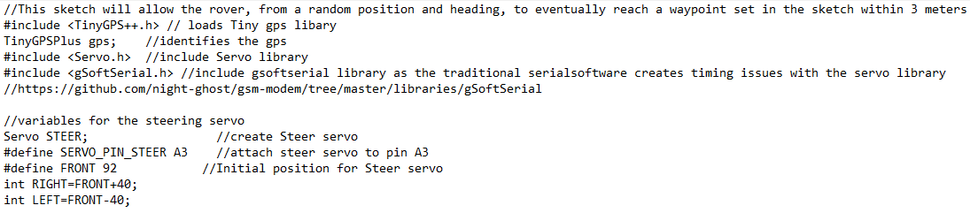
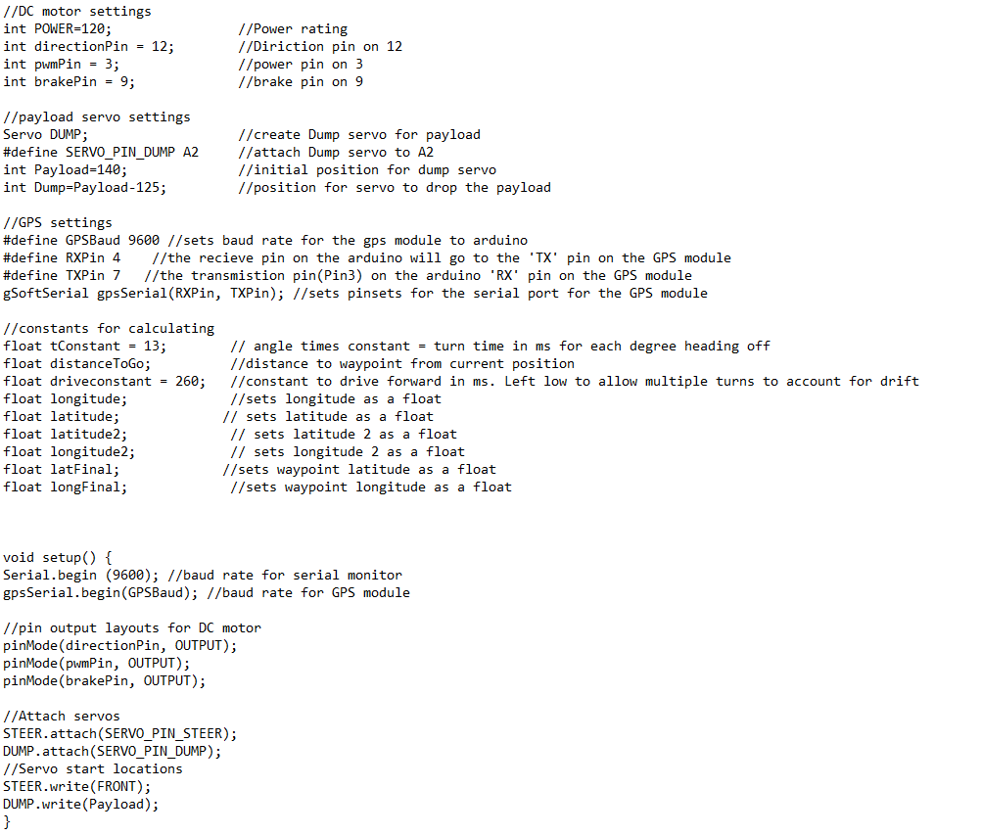
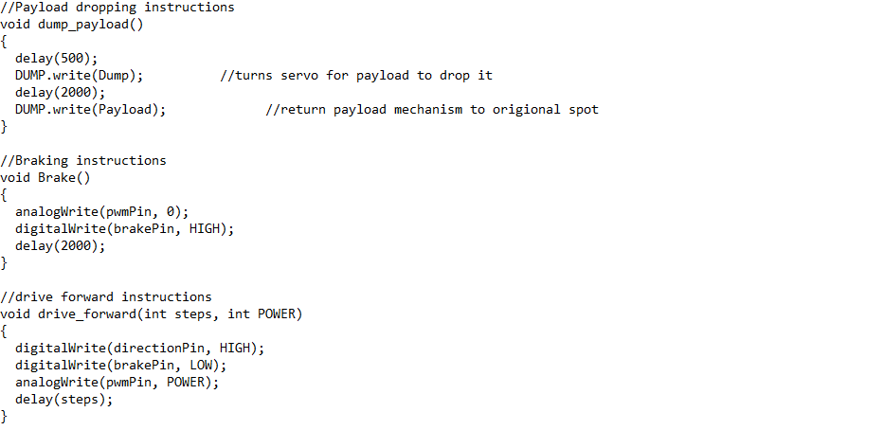
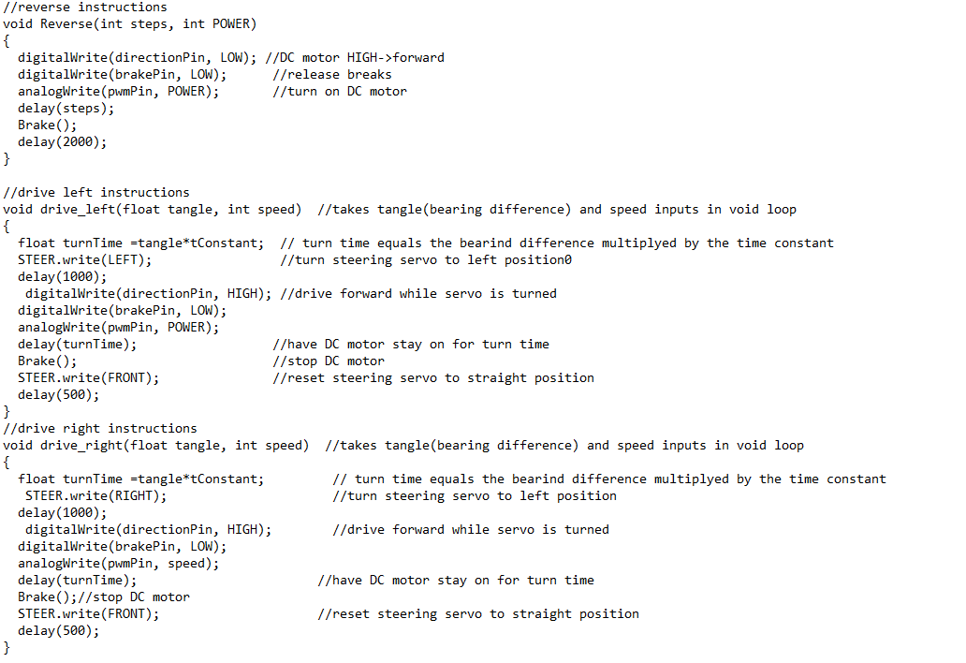
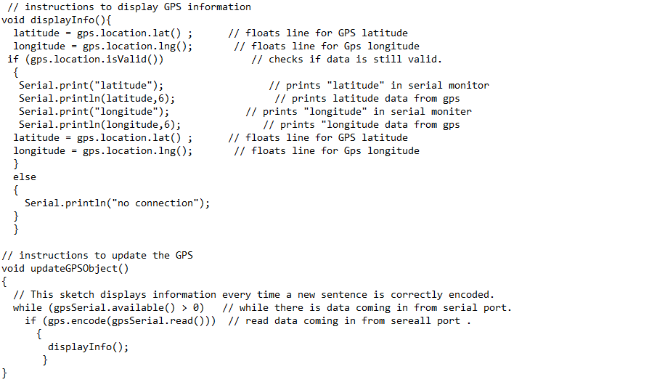

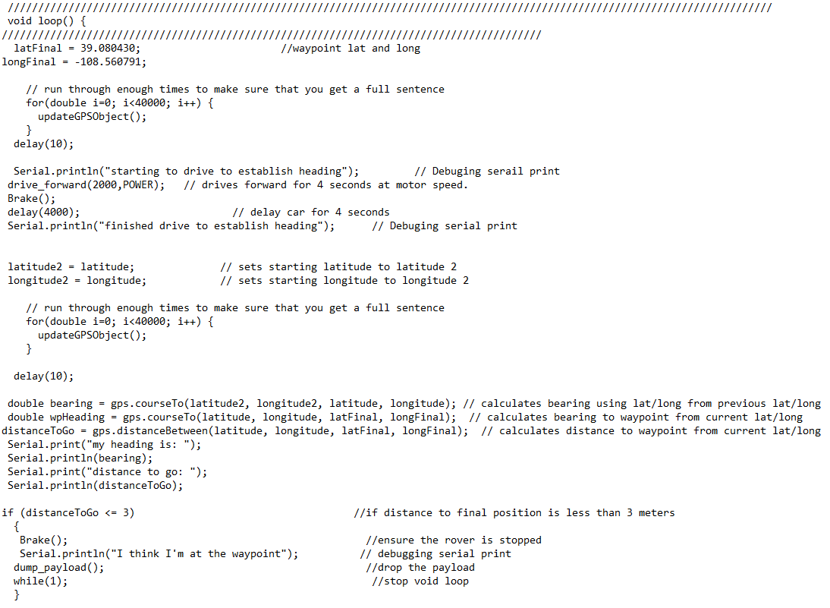
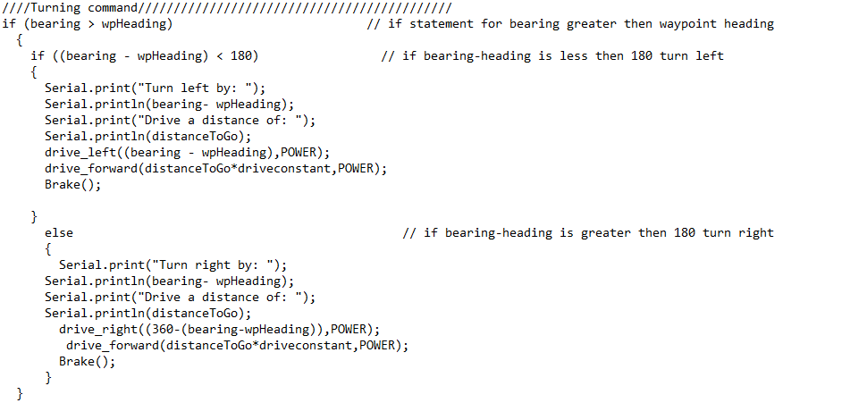

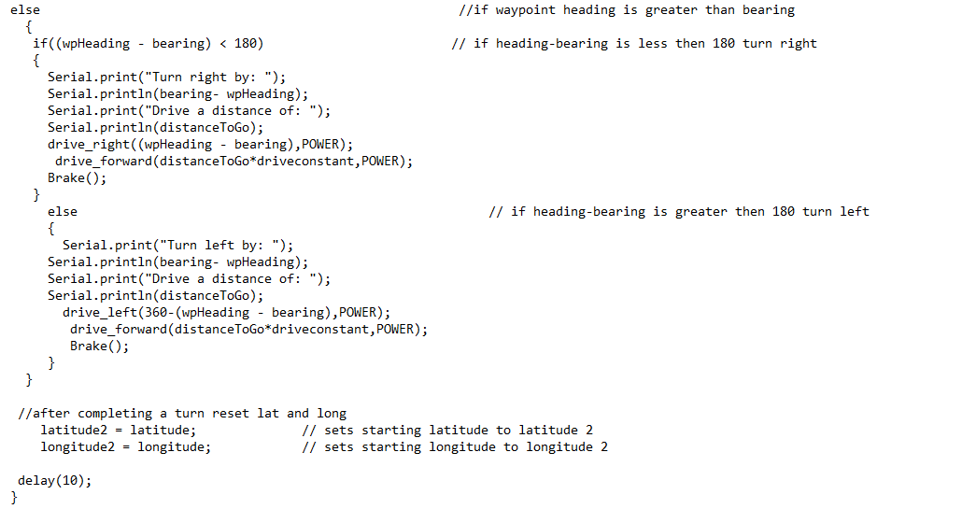
Mission 4B (Extra Credit)
N/A
*All mission are now complete, no more following modifications will be evaluated.

