Due: 04/19/2023
Rover Mission #3 – Basic GPS Navigation
- Point due North. From an arbitrary start location and heading, navigate so that the
rover is pointing due North. Point north within +/- 20° and complete the mission
within 180 seconds.
*Requires two consecutive successful runs
---------------------------------------------------------------------------------------------------------------------
Results
PASSED
Rover Version
Rover V.3 was used to attempt this mission which included a DC motor, Arduino uno, L298P shield R3 motor driver module, Futaba S3003 standard servo, 9.6V 2000mAH NiMH battery pack, MG90S micro servo,433 MHz RF receiver and a Adafruit Ultimate GPS breakout module.
Arduino Code
Mission 3A
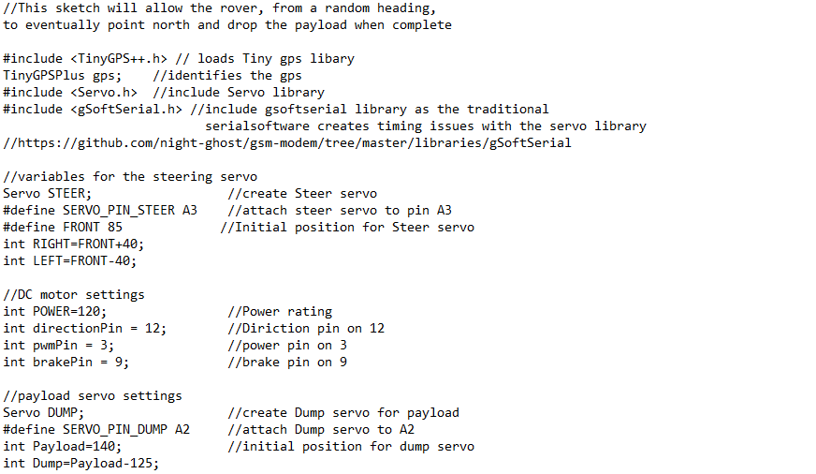

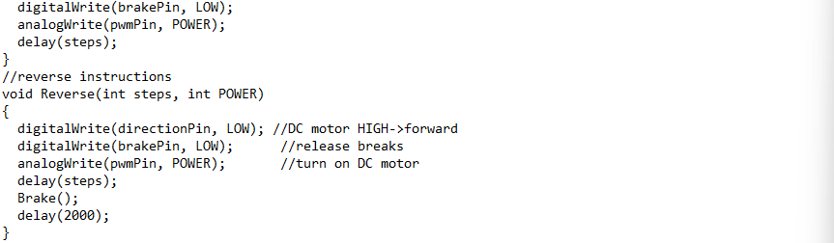
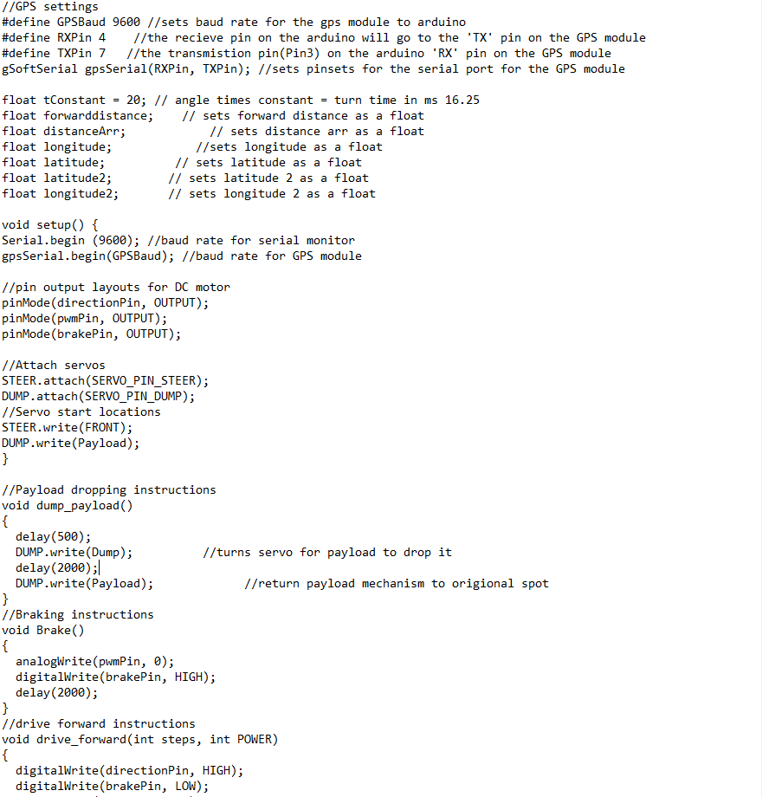

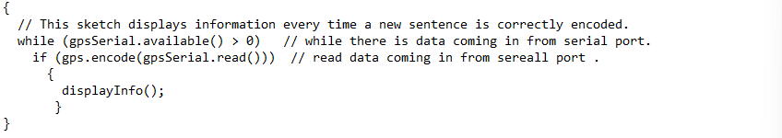
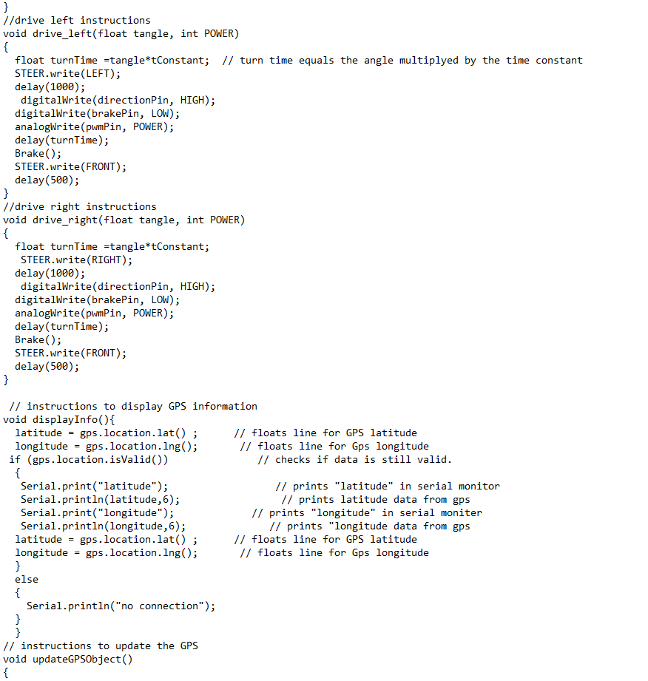

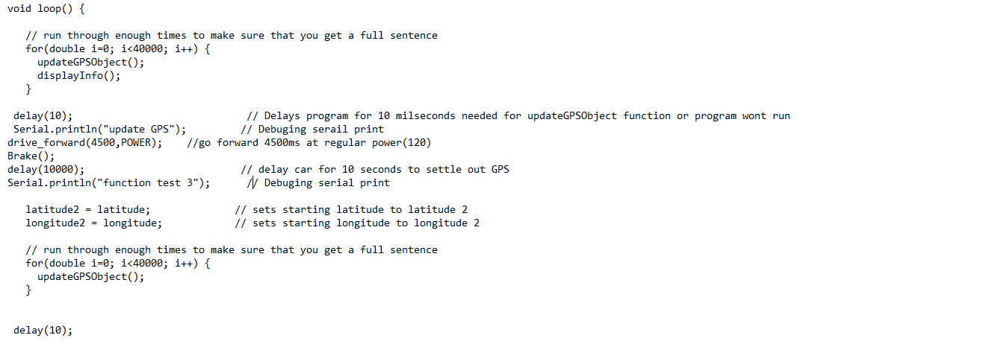

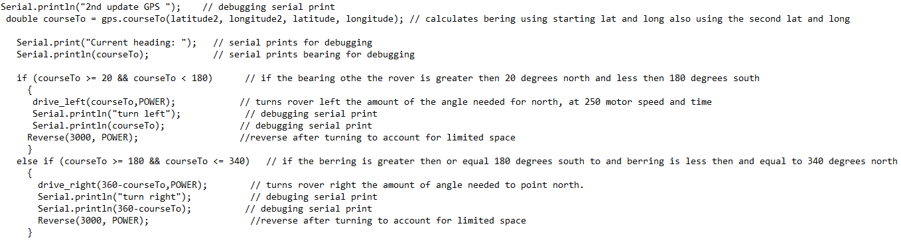

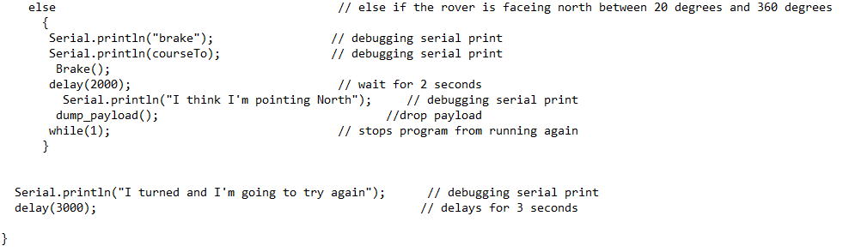

Following Modifications
Moving forward to Mission #4 we are considering adding in an Arduino Mega or Arduino slave since the sensor, Arduino and RF receiver libraries are acting weird for Mission 4B.

