Due: 03/29/2023

Rover Mission #2 – Obstacle Avoidance

1. Drive in an enclosed area (at least 10’x10’) without contacting walls or obstacles. The  
   mission will last 60 seconds.
2. Drive forward to waypoint 30’ directly ahead of robot. Demonstrate avoidance algorithm by continuing to original waypoint after navigating around a single obstacle. The rover should stop within 5ft of the marked waypoint and complete the mission in under 120 seconds.

*Without GPS Navigation

*Requires two consecutive successful runs

---------------------------------------------------------------------------------------------------------------------

Results

**PASSED**

**Rover Version**

Rover V.2 was used to attempt this mission which included a DC motor, Arduino uno, L298P shield R3 motor driver module, Futaba S3003 standard servo, 9.6V 2000mAH NiMH battery pack, MG90S micro servo,433 MHz RF receiver and a HC-SRO4 ultrasonic sensor.

**Arduino Code**

***Mission 2A***

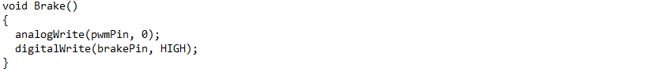

***Mission 2B***

**Following Modifications**

Moving forward to Mission #3, we plan to add in a GPS module to help navigate itself using GPS coordinates which is our overall most important customer requirement.