Due: 03/8/2023

Rover Mission #1 – Rolling Chassis

1. Drive in a ~10ft square pattern, stop at original location and place marker. The marker should be within 3ft of the rover’s original location and the mission should be completed within 60 seconds.
2. Drive straight for 15-30ft and place physical marker. The rover will read the specific intended distance from an RF transmitter beacon at the starting location. The marker should be within +/- 10% of the specified drive distance and the task should be completed in less than 30 seconds.
   * The distance to drive will be transmitted as a 12-character message. The distance will be two digits preceded by an ‘X’. The remainder of the message will be padded with ‘Z’ characters. For example, the message for the rover to travel 15 feet would be “X15ZZZZZZZZZ”.
   * The distance to be traveled will be continuously transmitted from the RF beacon at 5 second intervals.

*Requires two consecutive successful runs

---------------------------------------------------------------------------------------------------------------------

Results

**PASSED**

Rover V.1 was used to attempt this mission which included a DC motor, Arduino uno, L298P shield R3 motor driver module, Futaba S3003 standard servo, 9.6V 2000mAH NiMH battery pack, MG90S micro servo and 433 MHz RF receiver.

**Arduino sketch**

***Mission 1A***

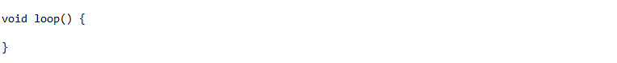

***Mission 1B***

**Following modifications**

Moving forward to Mission #1 we plan to add in a swivel sweep sensor system in the front center of the rover that covers 120°. We are also going to replace the current DC motor with a new brushless DC motor to improve the power and see if its capable of driving through grass.