Decision Matrices
Using a 0-to-100-point scale, each team member individually weighted the importance of the requirements then took the average to come up with a final weight. Following this, we graded the design ideas being “-1” = Not Ideal, “0” = Neutral and “1” = Ideal.
Chassis - Pre-built kit​
3D printing and a pre-built kit was noticed to be the most promising since they are capable of holding all modules while being sturdy enough to handle the drop and water test. Mainly focusing on durability and workability/repairs for our engineering analysis. Our team decided to go with the pre-built kit since it would cut on budget costs dramatically because we found an old RC car kit laying around. This won’t affect our quality of our rover since we believe it will function properly with the right hardware and coding.
Table 1. Decision matrix for chassis

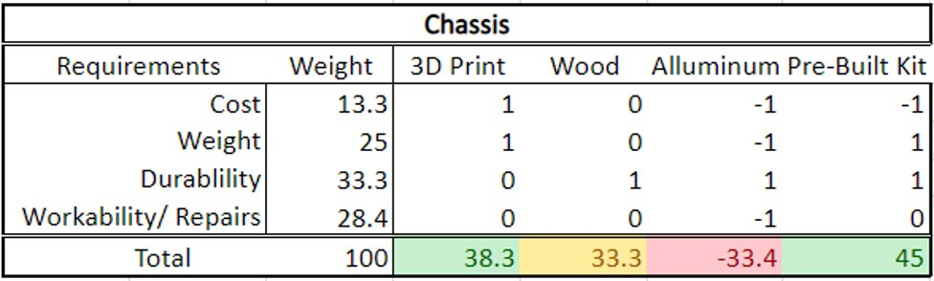
Movement – Tires
A tank tread and tires were noticed to be the most promising since they are capable of maneuvering through rough terrain and attaining a tight turning radius. Mainly focusing on turning radius and ability to drive through rough terrain for our engineering analysis. Our team decided to go with the tires for our movement mechanism since they came with the old RC car kit which will cut on costs. We believe the tires will be able turn and ride through rough terrain just as well as the tank tread would.

Table 2. Decision matrix for movement mechanism

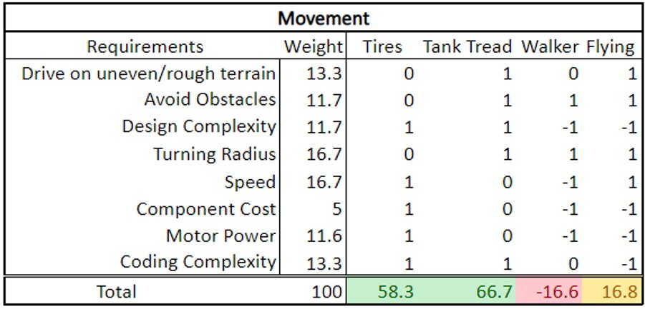

Payload dropping mechanism – Dump system
A dump and grip system were noticed to be the most promising since they are capable of holding onto the payload till the desired drop zone and are both responsive. Mainly focusing on security while driving and coding complexity for our engineering analysis. Moving forward with the dump system, we believe this system will be the least complicated while still being capable of completing the missions.
Table 3. Decision matrix for payload dropping mechanism
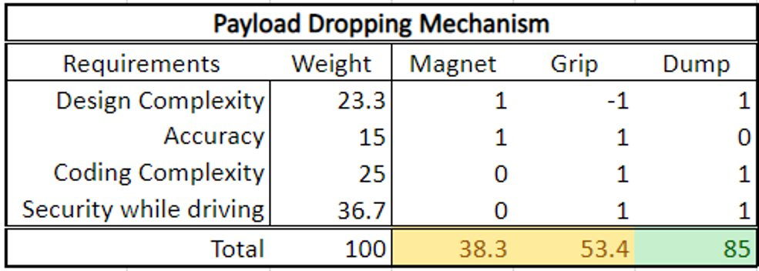

Engineering Analysis
Chassis – Pre-built kit
- Sturdy polymer frame can withstand drop test and water test
- Enough frame space to carry all modules comfortably
- Lightweight (<2 lbs)
- Recycled/free kit
Movement – Tires
- Withstands rough/uneven terrain
- Lightweight
- Capable of moving 30 ft. in 25 seconds
- Easy to maneuver
- Tight turning radius
- Responsive movement
- Recycled/free kit
Payload Drop – Dump
- Holds payload comfortably till desired drop zone
- Responsive drop
- Minimal movement of payload after drop
- Easier to assemble

