Rover Bill of Materials
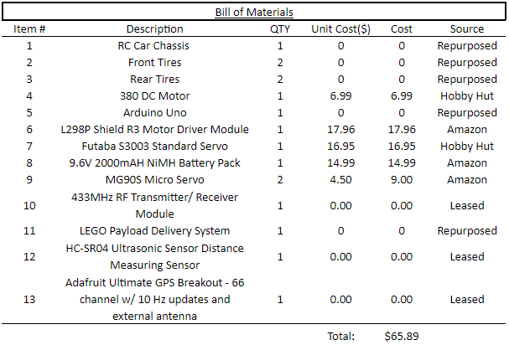
Item Links
[1-3] - https://www.worthpoint.com/worthopedia/radio-shack-wind-streaker-sky-driver-1750258 442
[4] - https://www.hobbyhutmodels.com/
[5] - https://www.amazon.com/Arduino-A000066-ARDUINO-UNO-R3/dp/B008GRTSV6/ref=s r_1_3?crid=2PVWQC1B7OVMX&keywords=arduino+uno&qid=1678295814&s=industrial&sp refix=arduino+uno%2Cindustrial%2C120&sr=1-3
[6] - https://www.amazon.com/Shield-Driver-Module-H-Bridge-Arduino/dp/B00WN4UB8W
[7] - https://www.hobbyhutmodels.com/
[8] - https://www.amazon.com/2000mAh-Battery-Robots-Smart-Charger/dp/B00KG4PWWQ
[9] -https://www.amazon.com/Replace-Helicopter-Airplane-Controls-Vehicle/dp/B09KXM5L7Z /ref=sr_1_8?keywords=mg90s&qid=1678295308&sr=8-8
[10]-https://www.jameco.com/z/433MHZ-TXRX-Major-Brands-433MHz-RF-Transmitter-
Receiver-Pair_2297703.html
[12] - https://www.sparkfun.com/products/15569
[13] - https://www.adafruit.com/products/746

