Decision Matrices
Using a 0-to-100-point scale, each team member individually weighted the importance of the requirements then took the average to come up with a final weight. Following this, we graded the design ideas being “-1” = Not Ideal, “0” = Neutral and “1” = Ideal.
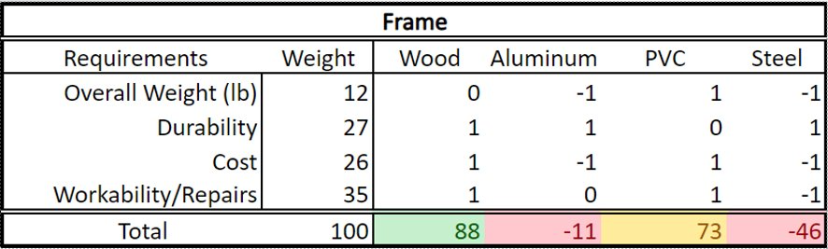

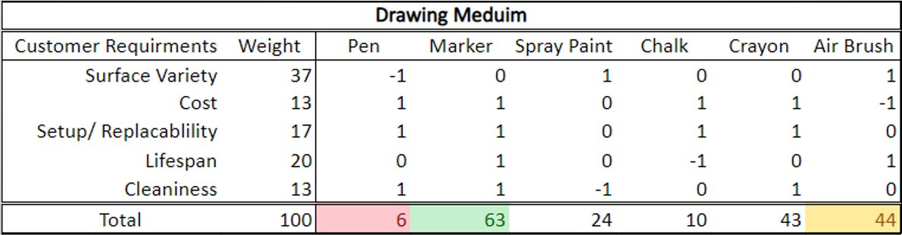

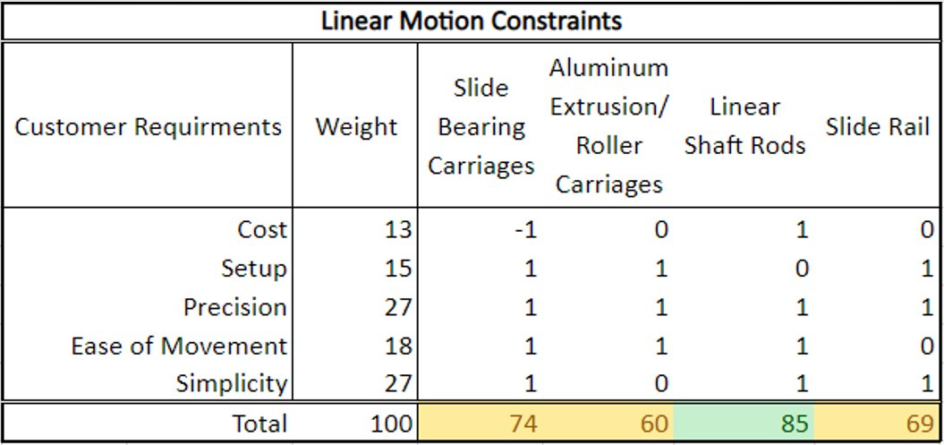

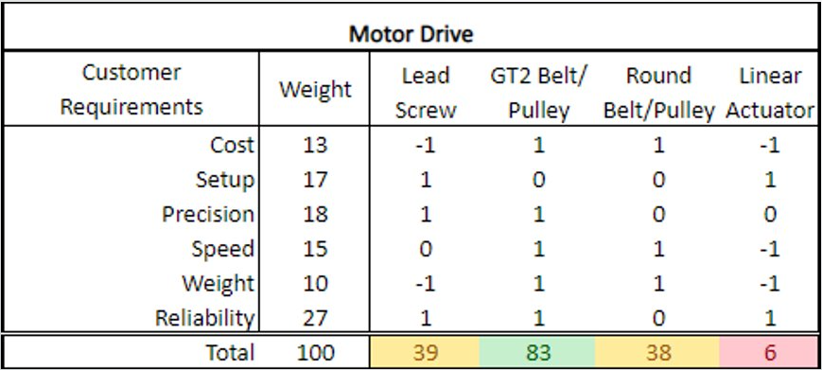

Engineering Analysis

Deflection on linear shaft rods
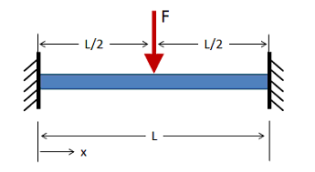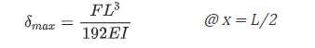
F = 5 lbs.
L = 48 in.
E = 29000 ksi
D = 0.375 in.
I = 9.707x10⁻⁴ in.⁴

Theoretical Deflection = -0.102 in.
Actual Deflection = ~ -0.120 to -0.125 in.

