Arduino Ultrasonic Range Finder

**Overview**

This Arduino tutorial utilizes a HC-SR04 Ultrasonic Distance Measuring Sensor (<https://www.sparkfun.com/products/15569>) module as a range finder to find the distance the module is away from an object. The sketch gives the user a prompt after which the distance, in inches, is given from the sensor to an object in front of it.

This sketch will be utilized in the autonomous rover to prevent it from running into obstacles in Mission 2. In Mission 2.a the rover will have to drive in an enclosed are without contacting any walls or obstacles and in Mission 2.b it will have to navigate around a single obstacle and stop within 5ft of a marked waypoint.

**Requirements**

Hardware requirements to complete the sketch in this tutorial include: 1 Breadboard, 1 Arduino Uno, 1 USB cable A to B, 1 HC-SR04 Ultrasonic Distance Measuring Sensor, and 4 jumper wires (M/M).

Software requirements include the Arduino IDE program (or equivalent).

**Setup**

1. First wire up the hardware as ween in Figure 1.
2. Connect the Arduino Uno to computer with USB cable.
3. Open Arduino IDE and upload the Range_Finder sketch to the Arduino to run the program.

The sketch will prompt the user for an input through the serial monitor in which it will give the distance in inches of an object in front of the sensor.

**Code**

//This sketch utilizes the HC-SR04 Ultrasonic Distance Measuring Sensor

//to locate the distance in inches from the sensor to an object in front of it

// Reference: https://randomnerdtutorials.com/complete-guide-for-ultrasonic-sensor-hc-sr04/

int echoPin = 2; // Echo

int trigPin = 3; // Trigger

long duration, inches;

void setup() {

Serial.begin (9600); //baud rate

pinMode(trigPin, OUTPUT); //pin set for ping send

pinMode(echoPin, INPUT); //pin set for echo recieve

}

void loop() {

// The sensor is triggered by a HIGH pulse of 10 or more microseconds.

// Give a short LOW pulse beforehand to ensure a clean HIGH pulse:

digitalWrite(trigPin, LOW);

delayMicroseconds(5);

digitalWrite(trigPin, HIGH);

delayMicroseconds(10);

digitalWrite(trigPin, LOW);

pinMode(echoPin, INPUT); //read high pulse of sensor

duration = pulseIn(echoPin, HIGH); //time in microseconds from sent ping to echo recieved ping

inches = (duration/2) / 74; //Convert time of sonar ping into distance in inches

Serial.println("Input any variable to find distance from range finder to object"); //user input prompt

while(Serial.available()){Serial.read();}

while (!Serial.available()) { }

Serial.print(inches);

Serial.println("in, ");

delay(250);

}

**References**

This tutorial was created with help from https://howtomechatronics.com/tutorials/arduino/ultrasonic-sensor-hc-sr04/.

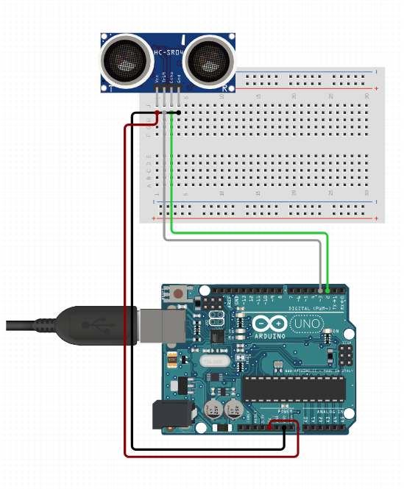

Figure : Wiring diagram for the SR04 Ultrasonic Distance Measuring Sensor to Arduino.