Arduino RF Transmitter and Receiver

**Overview**

This Arduino tutorial utilizes a 433MHz RF Transmitter/Receiver Module (<https://www.jameco.com/z/433MHZ-TXRX-Major-Brands-433MHz-RF-Transmitter-Receiver-Pair_2297703.html>) to transmit and receive a message between two Arduinos. One Arduino transmits a message through RF waves to another Arduino with a receiver. The receiving Arduino takes the message and tells whether the encoded number is even or odd through the serial monitor.

The RF transmitter and receiver will be utilized by the autonomous rover to determine the drive distance in Mission 1.b to drop its payload and for the final Mission to receive the GPS coordinates to drop its payload.

**Requirements**

Hardware requirements to complete this tutorial include: 2 breadboards, 2 Arduino Uno, 2 USB cables A to B, 1 433MHz RF Transmitter/Receiver Module (https://www.jameco.com/z/433MHZ-TXRX-Major-Brands-433MHz-RF-Transmitter-  
Receiver-Pair_2297703.html), and 6 jumper wires (M/M).

Software requirements include the Arduino IDE program (or equivalent) and the RadioHead library (<http://www.airspayce.com/mikem/arduino/RadioHead/RadioHead-1.41.zip>).

**Setup**

1. Wire up the hardware for the transmitter as seen in Figure 1.
2. Wire up the hardware for the receiver as seen in Figure 2.
3. Open the Arduino IDE and install the RadioHead library.
4. 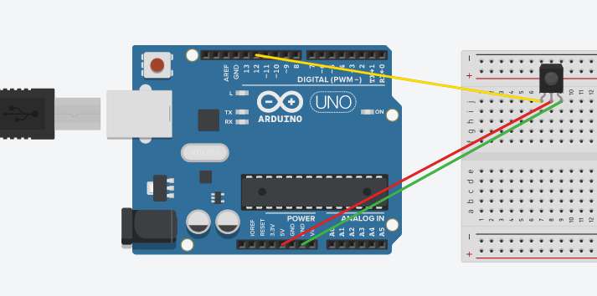Upload the sketches in Arduino IDE to their respective Arduinos to run the program.

Figure : Wiring diagram for transmitter Arduino

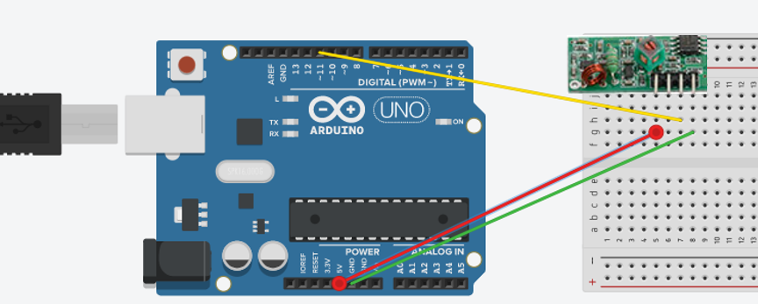

Figure : Receiver wiring diagram.

**Transmitter Sketch**

//This sketch takes and encodes a message and transmits it to another Arduino

//this sketch uses the 433MHz RF Transmitter/Receiver Module

//This sketch requires the RadioHead library

//(http://www.airspayce.com/mikem/arduino/RadioHead/RadioHead-1.41.zip)

//reference https://randomnerdtutorials.com/rf-433mhz-transmitter-receiver-module-with-arduino/

#include <RH_ASK.h> //Makes Arduino use the RadioHead library

#include <SPI.h> // Not actually used but needed to compile

RH_ASK driver;

void setup()

{

Serial.begin(9600); //sets baud rate

if (!driver.init())

Serial.println("init failed"); //if driver fails reports through serial monitor

}

void loop()

{

const char *msg = "X15ZZZZZZZZZ"; //turns message into character

driver.send((uint8_t *)msg, strlen(msg)); //takes message and transmits

driver.waitPacketSent();

delay(5000); //wait 5 seconds until another transmission

}

**Receiver Sketch**

//This sketch takes a encoded transmition from another Arduino

//and deciphers if the number in it is odd or even

//this sketch uses the 433MHz RF Transmitter/Receiver Module

//This sketch requires the RadioHead library

//(http://www.airspayce.com/mikem/arduino/RadioHead/RadioHead-1.41.zip)

//reference https://randomnerdtutorials.com/rf-433mhz-transmitter-receiver-module-with-arduino/

#include <RH_ASK.h> //gets RadioHead from library

#include <SPI.h> // Not actualy used but needed to compile

RH_ASK driver; //creates RadioHead driver

void setup()

{

Serial.begin(9600); //baud rate for serial monitor

if (!driver.init()) //if driver fails to load...

Serial.println("init failed"); //print failed status

}

String start; //sets 'start' as a string

int out; //sets 'output' as an integer

String number; //sets 'number' as a string

void loop()

{

uint8_t buf[12]; //ensures only gathers 12 character transmission

uint8_t buflen = sizeof(buf);

if (driver.recv(buf, &buflen)) // Non-blocking

{

int i;

start = String((char*)buf); //turns data from transmitter as a string

number = start.substring(1,3 ); //gets 2nd and 3rd digits from start string

out = number.toInt(); //turns string number from 'number' string to integer

Serial.print(out); //prints number from 'out'

int EvenOrOdd = out %2; //compares 'out' to 2

if (EvenOrOdd==0) { //if EvenOrOdd is even by bolean comparison

Serial.println(" is even."); //prints 'is even

}

else { //if EvenOrOdd is 1 by bolean

Serial.println(" is odd."); //print 'is odd'

}

}

}

**References**

This tutorial was created with the help of https://randomnerdtutorials.com/rf-433mhz-transmitter-receiver-module-with-arduino/.